

**DIGITAL INFRARED THERMOMETER.**

**SY B.Tech. Minor Project Report**

SUBMITTED BY

**Akshay Kapase. [S207043]**

**Dhiraj Patil[S207080]**

**Shrihari Eknathe [S207099]**

**Shrikant Deshmukh[S207120]**

GUIDED BY

**Prof. Savita Pawar**

**SCHOOL OF ELECTRICAL ENGINEERING AND TECHNOLOGY**

**MIT ACADEMY OF ENGINEERING, ALANDI (D), PUNE-412105**

**MAHARASHTRA (INDIA)**

**NOV, 2020**



**DIGITAL INFRARED THERMOMETER.**

**SY B.Tech. Minor Project Report**

*submitted in partial fulfilment of the*

*requirements for the award of the degree*

*of*

**Bachelor of Technology**

*in*

**ELECTRONICS AND TELECOMMUNICATION ENGINEERING**

BY

**Akshay Kapase, Dhiraj Patil, Shrihari Eknathe, Shrikant Deshmukh**

**SCHOOL OF ELECTRICAL ENGINEERING & TECHNOLOGY**

**MIT ACADEMY OF ENGINEERING, ALANDI (D), PUNE-412105**

**MAHARASHTRA (INDIA)**

NOV, 2020



**CERTIFICATE**

It is hereby certified that the work which is being presented in the SY B.TECH Minor Project Report entitled **“**DIGITAL INFRARED THERMOMETER WITH PULSE OXIMETER**”,** in partial fulfilment of the requirements for the award of the **Bachelor of Technology in Electronics and telecommunication Engineering** and submitted to the **School of Electrical Engineering and Technology of MIT Academy of Engineering, Alandi (D), Pune, Affiliated to Savitribai Phule Pune University (SPPU), Pune** is an authentic record of work carried out during an Academic Year 2020-2021, under the supervision of **Mrs. Savita Pawar,** **School of Electrical Engineering and Technology.**

**Akshay Kapase PRN No.** **0120190225 Exam Seat No. S207043**

**Dhiraj Patil PRN No.0120190375 Exam Seat No. S207080 Shrihari Eknathe PRN No.** **0120190480 Exam Seat No. S207099**

**Shrikant Deshmukh PRN No.0120190593 Exam Seat No. S207120**

| *Signature of Project Advisor* | *Signature of Dean* |
| --- | --- |
| **Mrs. Savita Pawar** | **Dean** |
| School of Electrical Engineering and Technology, | School of Computer Engineering and Technology, |
| MIT Academy of Engineering, Alandi (D), Pune | MIT Academy of Engineering, Alandi(D), Pune |

**(STAMP/SEAL)**

| *Signature of Internal examiner/s* | *Signature of External examiner/s* |
| --- | --- |
| *Name………………………………* | *Name………………………………* |
| *Affiliation…………………………* | *Affiliation…………………………* |

# ACKNOWLEDGEMENT

Our team want to express our gratitude towards our respected project advisor **Mrs. Savita Pawar** for her constant encouragement and valuable guidance throughout the completion of this project work. It would be impossible to count all the ways that she helped us during our project work, we want to thank her for all that she has done. We would also want to express our gratitude towards respected School Dean **Dr. D. Adhikari sir** for his continuous encouragement.

Team Members:

1. Akshay Kapase
2. Shrihari Eknathe
3. Dhiraj Patil.
4. Shrikant Deshmukh

# ABSTRACT

Our main goal is to design a contactless digital thermometer with pulse oximeter to measure the blood oxygen level.

Body temperature is the most basic and vital indicator of life. Measuring body temperature plays an important role in daily care. Infrared thermometer is mainly based on the principles of black body radiation to measure the human body's infrared radiation wavelength, followed by the measurement of body temperature, infrared sensors used by it only to absorb the infrared radiation of human body without any emission, which uses a passive non-contact measurement method and can effectively prevent cause harm to the human body.

The pulse oximeter is use to measure the oxygen level in the human blood. This is the effective way to check the important parameters related to health at a single platform.

# List of Figures

Figure 1 Block Diagram 15

Figure 2 Circuit Diagram in Proteus 15

Figure 3 Outer body of prototype 16

Figure 4 A.3D model of prototype 16

Figure 5 B.3D model of prototype 17

Figure 6 C.3D model of prototype 17

Figure 7 Hardware Circuit Connection 18

Figure 8 Flowchart 20

# List of tables

Table 1 Bill of materials 19

Table 2 Sensor parameters 19

**Table of Contents**

ACKNOWLEDGEMENT 4

ABSTRACT 5

List of Figures 6

List of tables 7

1 INTRODUCTION 9

1.1 Motivations 9

1.2 Problem Statement 9

1.3 Objectives and Scope 10

2 Literature Review 11

2.1 LITERATURE SURVEY 1 11

2.2 LITERATURE SURVEY 2 12

2.3 LITERATURE SURVEY 3 13

3 System Design 15

3.1 block diagram 15

3.2 circuit diagram 15

3.3 mechanical drawing 16

3.4 Snapshot of connections 18

3.5 hardware and software requirements 18

3.6 Bill of materials 19

3.7 Sensors parameters 19

4 implementation and result 20

4.1 Algorithm and flowcharts 20

4.2 Result 21

4.3 Discussion 21

5 Conclusion and future scope 22

References 23

Appendix Sensors specification 24

# 1 INTRODUCTION

## 1.1 Motivations

Body temperature is the most basic and vital indicator of life. Measuring body temperature plays an Important role in daily care. This is most important thing in this pandemic covid-19 situation to measure the body temperature rapidly with accuracy to ensure the safety of people.

The traditional mercury thermometer needs to measure about 5 minutes under the armpits and needs to be read by human eyes. Therefore, there are many drawbacks with traditional mercury thermometer. With the development of infrared technology, infrared thermometers have also been recognized by the public due to their safety and rapidity. Compared with the traditional thermometer, the infrared thermometer is safe to use and has convenient measurement and short measuring time.

Another important parameter is oxygen level in a human blood. This can be easily monitored using pulse oximeter. It is a non-invasive devise that estimates the amount of oxygen in the blood. If the oxygen level goes outside the typical range, it may cause chest in pain, confusion, headache, rapid heartbeat.

So due to this major benefit to our health, it is necessary to design a digital non-contact infrared thermometer with pulse oximeter to track all this important parameter

## 1.2 Problem Statement

Infrared thermometers provide the perfect solution to non-contact temperature measurement with pulse oximeter which help to measure oxygen level in the blood. The goal of this project is to create a functional, accurate, and durable digital infrared thermometer with pulse oximeter.

## 1.3 Objectives and Scope

1. User friendly device
2. Accuracy in the measurement of readings
3. Suitable temperature range
4. Cost effective
5. Multi-Purpose use
6. Portable and durable
7. Good battery life

# 2 Literature Review

## 2.1 LITERATURE SURVEY 1

**Title:** Development of a Non-contact Infrared Thermometer **Year:**2017

**Journal:** International Conference Advanced Engineering and Technology Research (AETR 2017)

**Author:** Jing Zhang

**Objective/Aim:** Due to the disadvantages of traditional mercury thermometers, such as longer measurement time and necessity of contact with the human body, a thermometer that uses infrared sensors to detect temperature without contact is designed.

**Analysis of System Structure:** The design of the microcontroller-based controller, the Infrared temperature sensor directly to the collected signal for internal amplification and data processing and send it into the microcontroller, the microcontroller is to achieve LCD display and over-temperature alarm.

**Hardware Circuit Design:**

1. Temperature Measurement Circuit Design
2. SCM
3. Alarm Circuit
4. Design of Display Circuit

**Software Design:** The design of software program uses Keil uVsion4 compiler software.

**Results:**

1. After comparison, through the temperature tests on different parts of the body measured by infrared thermometer and mercury thermometer, the result of infrared thermometers is small different with mercury thermometer, at the same time, temperature values of different parts of body are different.
2. In the testing process, there is a temperature difference in the infrared thermometer measurement, so it is recommended to use multiple measurements in the specific use and to take the average value.

**Conclusion:**

1. It has the fast response, safety and other characteristics compared with the mercury thermometer.
2. At the same time, the over-temperature alarm, LCD display and other functions are designed to make it more perfect.

**Link of the Paper:** [**Click Here**](https://www.atlantis-press.com/article/25892853.pdf)

## 2.2 LITERATURE SURVEY 2

**Title:** Infrared Thermometer **Year:** 2012

**Journal:** Medical Development Division Ministry of Health Malaysia

**Author:** Madam Sin Lian Thye

**Objective/aim:** The objective of this systematic review was to assess the safety, efficacy/effectiveness and cost-effectiveness of Infrared thermometer for fever detection in a hospital or primary care setting.

**Inclusion Criteria:**

1. Patients: Patients with fewer or without fewer
2. Outcome: Fever detection, sensitivity, specificity, ROC, safety, adverse events, economic evaluation
3. Study design: Diagnostic accuracy studies, systematic review, health technology assessment, cross sectional, randomised control trial

**Results and conclusions:**

1. Infrared tympanic thermometer in children: It also showed that the Infrared tympanic thermometer sensitivity and specificity was moderate. However, the sensitivity and specificity increased with higher cut of point of temperature defined as fever.
2. Infrared tympanic thermometer in adult: infrared tympanic thermometer was less accurate to reflect core body temperature than pulmonary artery catheter or mercury in glass oral thermometer

**Link of the Paper:** [**Click Here**](https://www.moh.gov.my/index.php/database_stores/attach_download/347/192)

## 2.3 LITERATURE SURVEY 3

**Title:** Infrared Temperature Devices for Infectious Disease Screening During Outbreaks.

**Author:** Kwakye Peprah, Leigh-Ann Topfer

**Objective:** The objective of the ECRI Clinical Evidence Assessment was to review the literature on the accuracy of IR temperature screening devices for identifying visitors or staff entering health care facilities who may have potentially infectious diseases

**Criteria:**

* It provided sensitivity and specificity of hand-held thermometer guns
* Fever detection, sensitivity, specificity, ROC, safety, adverse events ETC.
* It permits temperature *measurement* from a distance without contact with the object
* Accuracy of temperature measurement.

**conclusions:**

* the operating distance from individuals being tested (operators wielding the devices too close or not close enough to the person undergoing screening can produce false high- or unusually low-temperature readings).
* the environmental temperature (environments that are too warm or too cold can affect the accuracy of the target temperature reading).
* non-contact IR temperature screening methods were effective for detecting infected persons.

**Link of the Paper:-** [Click here](https://www.google.com/url?sa=t&source=web&rct=j&url=https://cadth.ca/sites/default/files/covid-19/ha0004-non-contact-ir-temperature-screening-final.pdf&ved=2ahUKEwjoveaV9qTtAhUpwTgGHa_0BHMQFjATegQIGhAK&usg=AOvVaw3tQpp4A8PRlI1On5k2XePB)

# 3 System Design

## 3.1 block diagram

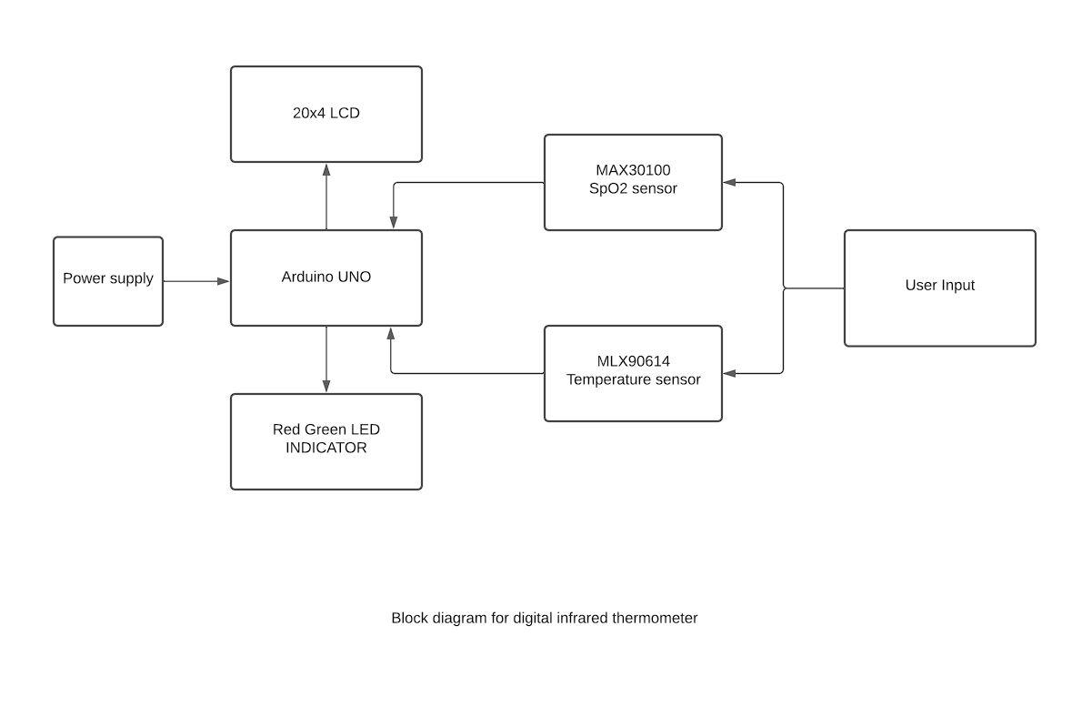

*Figure 1 Block Diagram*

**3.2 circuit diagram**

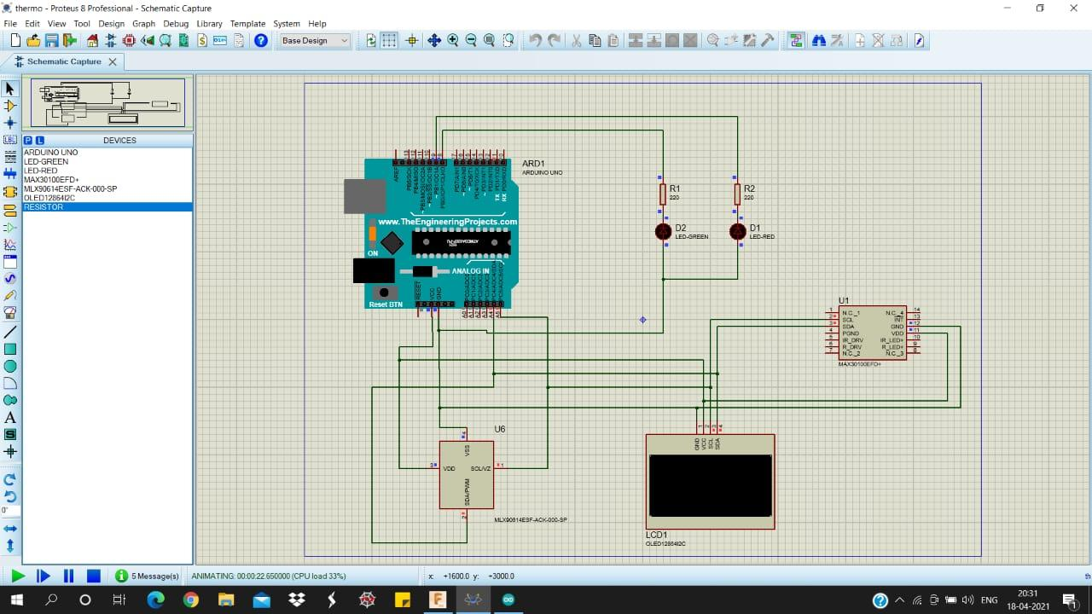

*Figure 2 Circuit Diagram in Proteus*

## 3.3 mechanical drawing

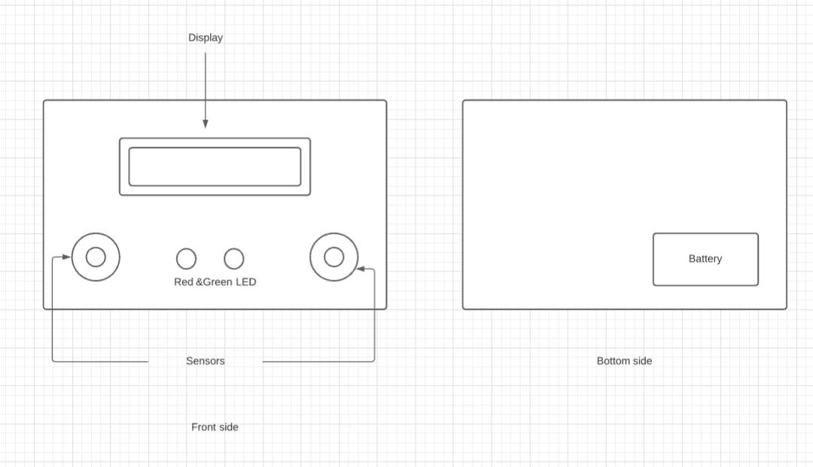

*Figure 3 Outer body of prototype*

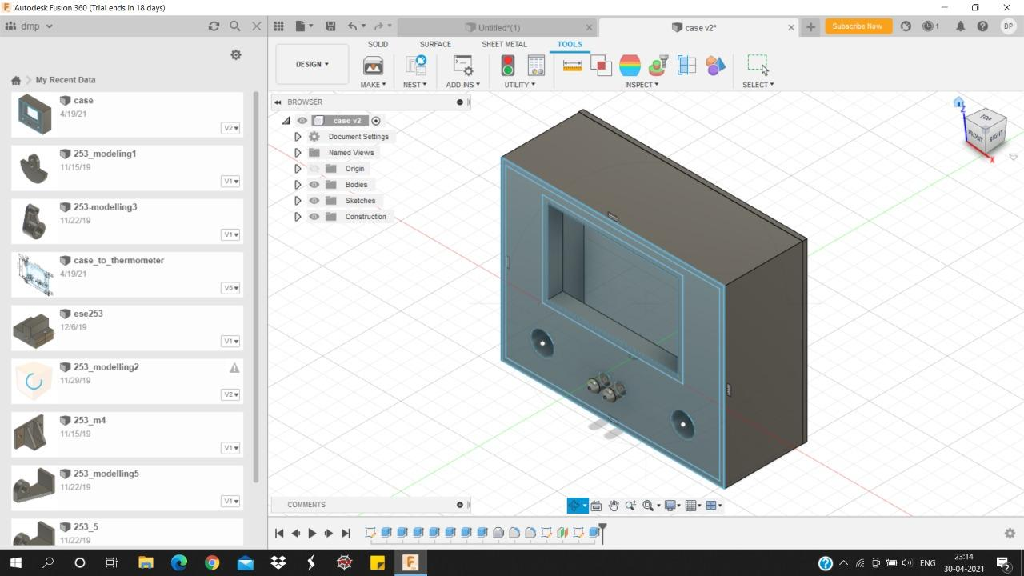

*Figure 4 A.3D model of prototype*

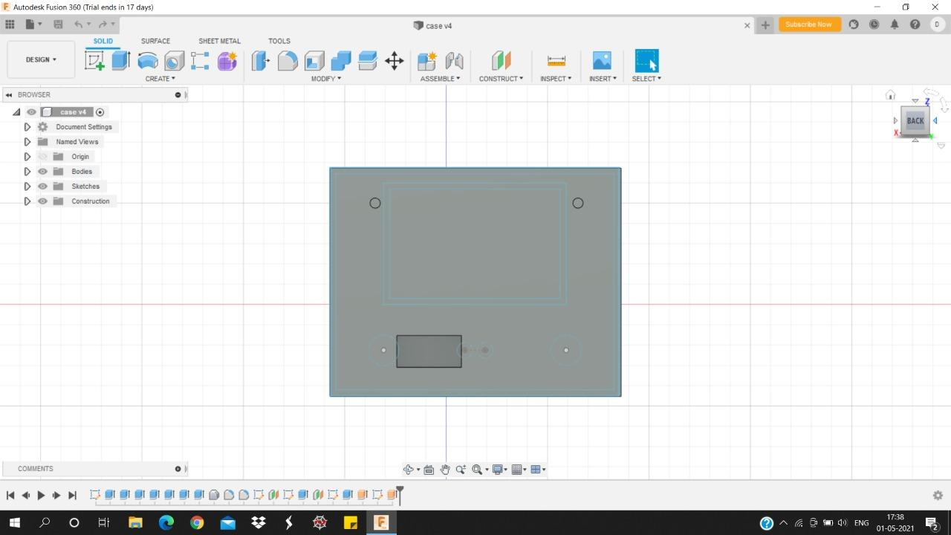

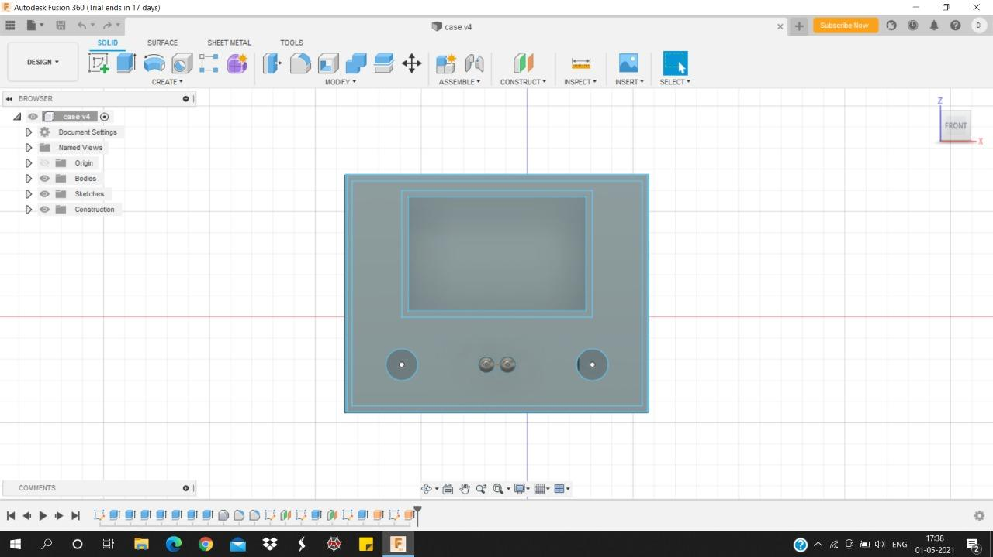

## 3.4 Snapshot of connections

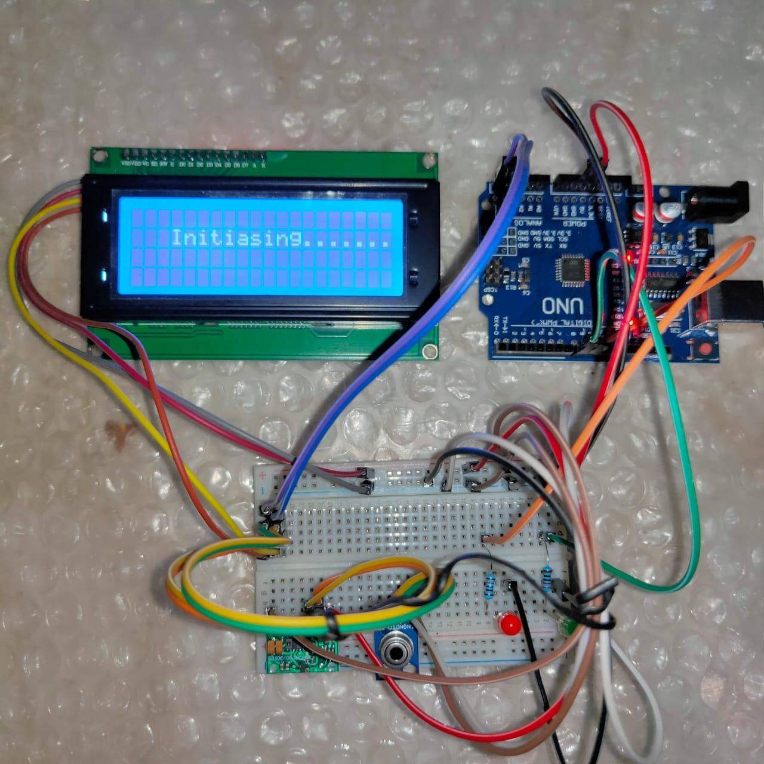

*Figure 7 Hardware Circuit Connection*

## 3.5 hardware and software requirements

1. Arduino uno
2. MLX90614 Infrared Thermometer sensor
3. MAX30100 Pulse Oximeter and Heart Rate Sensor
4. 20x04 Liquid crystal display
5. Connecting wires
6. Red and Green LEDs
7. 2x220 Ohm Resistors
8. Arduino IDE Software

## 3.6 Bill of materials

| **Components** | **Price** |
| --- | --- |
| 1. Uno Learning kit for Arduino | ₹ 750.00 |
| 1. Max30100 pulse oximeter Heart rate sensor | ₹ 259.00 |
| 1. MLX90614 Non-contact temperature sensor | ₹ 999.00 |
| 1. Lcd2004 parallel Lcd display with I2C interface | ₹ 450.00 |
| **Subtotal** | **₹ 2458.00** |

*Table 1 Bill of materials*

## 3.7 Sensors parameters

| **Sensor** | **MLX90614** | **MAX30100** |
| --- | --- | --- |
| **Measurement Range** | -70*C – 382.2*C | - |
| **Accuracy** | 99.62% | 0.1*C |
| **Power Supply** | 3V - 5V | 1.8V – 3.3V |
| **Operating temperature** | -40*C – 85*C | -40*C – 85*C |
| **Dimensions** | 8x6x2cm | 5.6x2.8x1.2mm |

*Table 2 Sensor parameters*

# 4 implementation and result

## 4.1 Algorithm and flowcharts

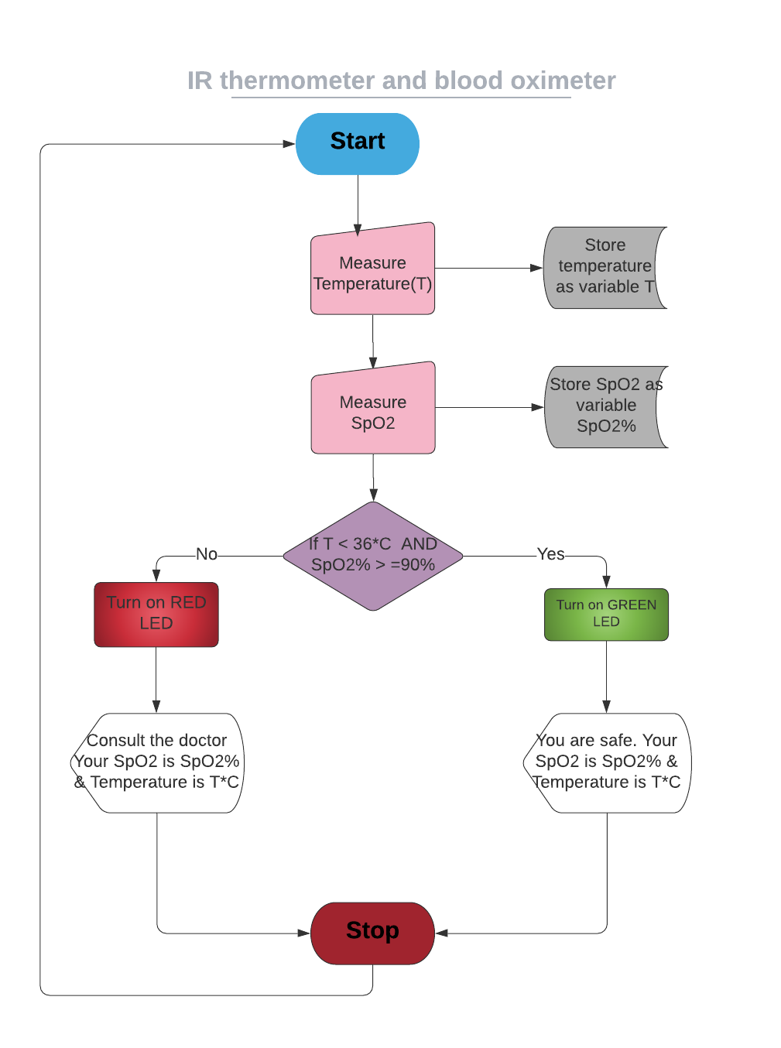

*Figure 8 Flowchart*

## 4.2 Result

This IR Thermometer & pulse oximeter used to measure the temperature & SpO2 level of humans. After the successful measurement the device will display the readings on the display and the LEDs will indicate the safety factor as a human is safe or not. If temperature or SpO2 level are in danger zone (i.e., temperature > 36*C & SpO2<90%) or both are in danger zone then red LED will indicate it. and if both parameter readings are in safe zone, then green LED will indicate it.

## 4.3 Discussion

At a present time, the IR thermometer & pulse oximeter available in market are not interconnected this leads the customers to buy two separate devices to measure this important parameter. As these devices are not connected hence, we do not get total knowledge about our health at a same time.

Hence our prototype helps in this situation a lot. It is a combination of IR thermometer and pulse oximeter. Another concern is to take readings. For this purpose, one person is needed to hold the device but it’s not safe in consideration to present COVID19 scenario. Hence this product is designed in such a manner that it can be hang on wall & the user can check herself/himself manually.

# 5 Conclusion and future scope

Our project aimed to develop the digital IR thermometer with pulse oximeter. The project objective has been successfully achieved where the sensors were successfully interfaced, however they need proper calibration to give more precise readings. Overall, the prototype is cost effective, easy to operate, portable and durable.

After completion of the implementation process there are some parts need to improve to be more efficient in the project. The first thing is calibrating the sensors with proper calibrating equipment. In future we are willing to enhance our prototype by connecting it to the liquid hand sanitizer dispenser. This will surely improve the quality of measurement and the overall process will become more convenient.

# References

# 1.http://en.wikipedia.org/wiki/Proximity sensor.

# 2. http://arduino.cc.

# 3. Brian W. Evans “Arduino Programming Notebook”.

# 4. Mario Bohmer , Beginning Android ADK with Arduino

# 5.http://arduino.cc/en/uploads/Main/arduino_Uno_Rev3-02-TH.zip.

# 6.http://arduino.cc/en/uploads/Main/Arduino_Uno_Rev3-schematic.pdf.

# 7.http://arduino.cc/en/Main/ArduinoBoardUno.

# 8. mlx90614 datasheet

# 9.http://www.digikey.com/catalog/en/partgroup/mlx90614-15/20353?WT.srch=1

# Appendix Sensors specification

**MLX90614**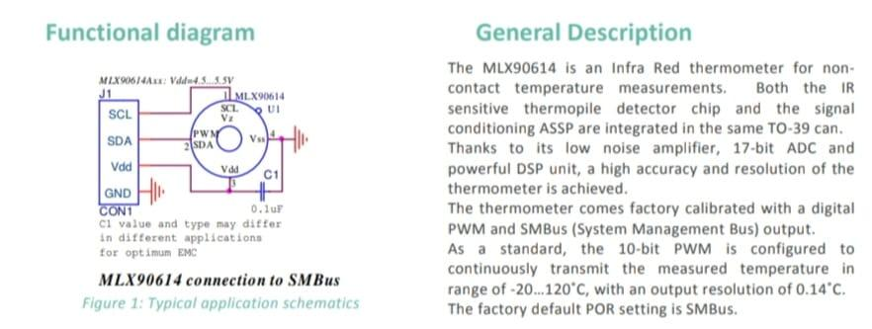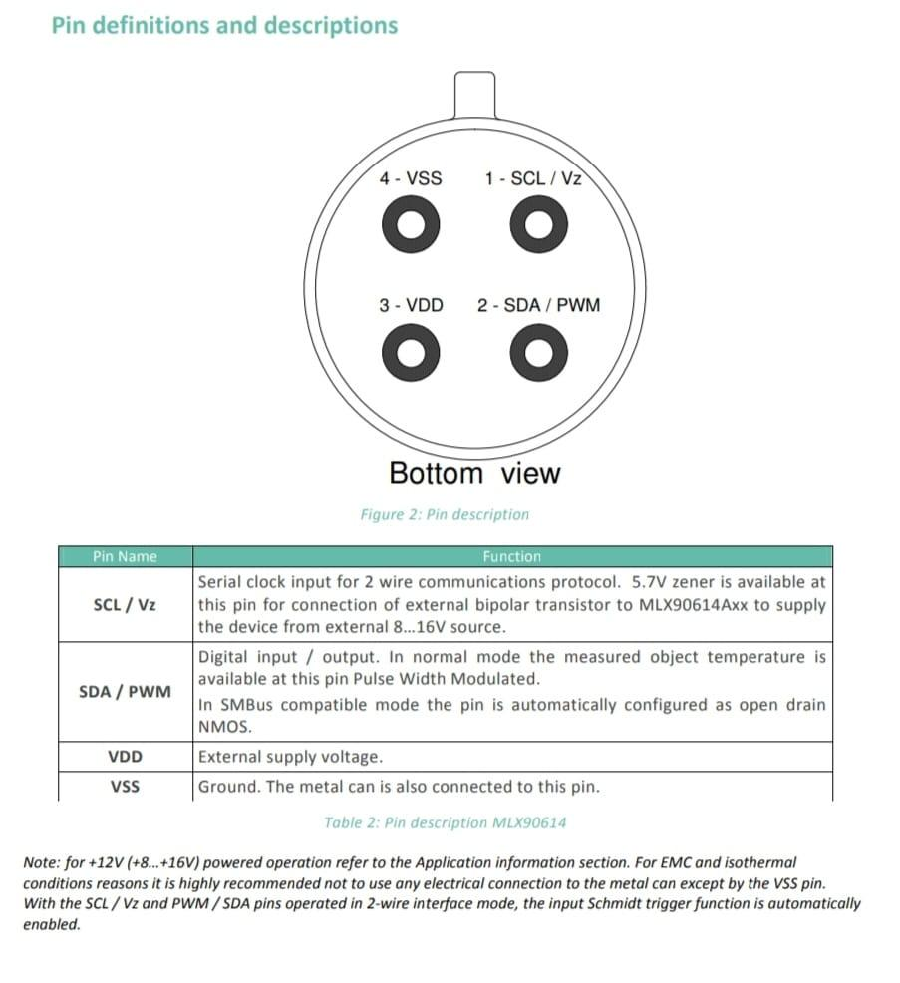

**MAX30100**

